User Manual for Software platform to control UTM

*Prathamesh Naik 160001037*

*Sai Kumar Reddy 160001043*

*Rahul Kumar 160001047*

*Vishal Maurya 160001061*

**1 Introduction**2

1.1 Things that the software will do 3

1.2 Objective of the software 3

**2 Configuration Instructions**4

2.1 Before you start... 4

2.2 A note about simulation mode 4

**3** **Features** 5

3.1 Reconnect Arduino 5

3.2 Giving input 5

3.3 Choosing a mode 6

3.4 Manual mode 6

3.5 Cycle mode 7

3.6 Export table 8

3.7 Graph 9

3.8 Live Panel 10

3.9 Motor simulation 10

3.10 Reset 10

# 1 Introduction

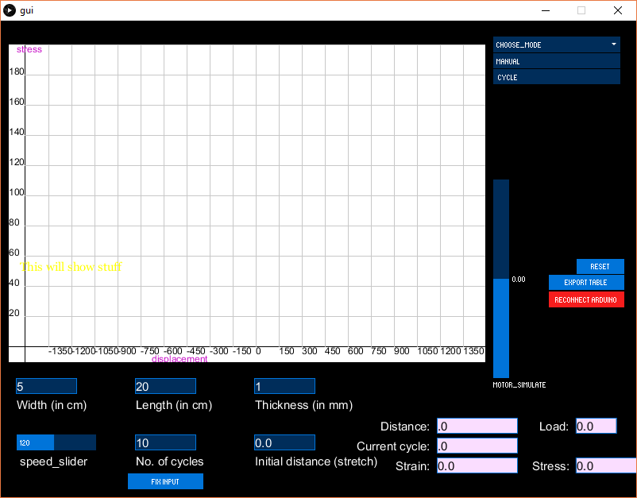

This software system is a software platform for a custom made Universal Testing  
Machine. (A UTM is materials testing machine, used to test the tensile strength and compressive strength of materials)

This system is designed to maximize a researcher's productivity by providing tools to assist in automating the material testing process. It can be used to find out the mechanical properties of polyimide sheets with and without SMA (shape memory alloy) coating. We’ve tried to make it easy to understand and use.

## 1.1 Things that the software will do

1. Control the Universal Testing Machine. You can specify speed and no. of cycles as well as control the motion of motor (which involves pausing it, restarting it and controlling direction) through GUI.
2. Get data output from the UTM, process it and run calculations on it, then show the  
   useful information, in the form of Graph or Excel file in addition to a live panel.

## 1.2 Objective of the software

The main objective of this software is to get values of stress on the polyimide sheet for different values of strain when it is elongated in the universal testing machine. This process will be repeated for the no. of cycles that you can specify.

The output will be shown in the form of graph or excel file. Based on the data received from UTM, certain mechanical properties of UTM would also be calculated and  
Shown.

The software will also show real-time data output while the UTM is running.

# 

# 2 Configuration Instructions

## 2.1 Before you start...

This software will facilitate communication between Universal Testing Machine (the  
electrical components include Arduino, Load Cell and Gear Motor) and the PC.

So first of all, make sure that the UTM itself is ready:

* Check that the load cell is in place and connected to amplifier
* Check that the gear motor is in place and connected to motor controller
* Check that both the amplifier and motor controller are connected to the Arduino

After ensuring this, connect the Arduino to PC using an USB cable.

Then, simply double click on the exe file to start the software.

## 2.2 A note about simulation mode

If you don’t have the UTM or Arduino with you, it is still possible to use the software. The software has a built in simulation mode, that simulates motor position using a slider and generates load cell values that approximate the expected real life behavior of load cell. The values generated also have some randomness, so every time you use the software in simulation mode, they will be different.

The simulation mode was mainly meant to be used for testing by developers, but you can play around with it. You can do everything with the simulation mode that can you do with the UTM connected. So you can follow all instructions in this manual using the simulation mode.

# 3 Features

### 3.1 Reconnect Arduino:

When you open the software, it tries to connect to Arduino. If the Arduino is connected to PC, the software will establish connection with it. If however Arduino is not connected, the software automatically switches to simulation mode.

In simulation mode, you can see the simulated motor position. You can also see the graph being generated using randomized load cell values.



Further a *“Reconnect Arduino”* button will be shown in red. You should first connect Arduino to PC and then click on *“Reconnect Arduino”*.

If the connection is successful, the *“Reconnect Arduino”* button will vanish and you can start using the software to control the motor.

### 3.2 Giving input:

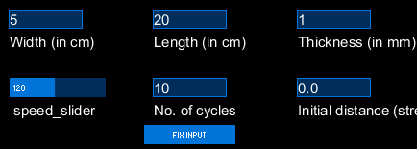

Use the input boxes for giving all the required data i.e. width, thickness, length, speed of the motor and number of cycles (required if you want to choose cycle mode). Make sure you give width, length, thickness as per the mentioned units. Press the “Fix input” button after you are done.

### 3.3 Choosing a mode:

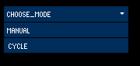

Once you give all the required parameters i.e. width, thickness, length, speed of the motor and number of cycles(optional) you can choose a mode using a dropdown selector at the top right of the display window. There are two modes: *manual mode* and *cycle mode*. Once you choose a mode you cannot change the inputs.

Choose *manual mode* if you want to control the motor manually, i.e. using up, down and pause buttons.

Choose *cycle mode* if you want the software to automatically control the motor for performing specified number of cycles.

### 3.4 Manual mode:

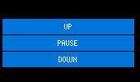

In manual mode, three buttons will get displayed “Up”, “Pause” and “Down”. Using this buttons, you can manually run the motor. By pressing Up button the motor moves in forward direction (elongates the sheet), by pressing Bottom button the motor moves in backward direction (compress the sheet) and by pressing pause the motor stops rotating.

### 

### 

### 

### 

### 3.5 Cycle mode:

In the cycle mode, the software automatically controls the motor in such a manner that the UTM performs the required number of cycles. To define a cycle, the software requires 3 points: the natural point of the cycle (when the material is in natural state, no elongation or compression), the uppermost point of the cycle and the lowermost point of the cycle.

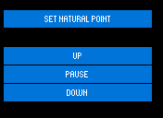

You first have to fix a natural point (origin for the cycle). First control the motor using “Up” and “Down” buttons to reach the desired natural point and then click “Set natural point”.

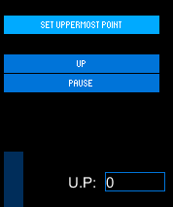

After fixing natural point you have to input uppermost point (the maximum elongation in sheet). You can give this uppermost point by giving the direct value in the “U.P.” input box or by using “Set Uppermost Point” button after moving the motor to the required point.

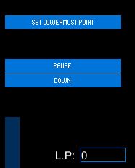

Similarly repeat the process for lowermost point. Use either the “L.P.” input box or the “Set Lowermost Point” button after moving the motor to the required position.

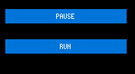

After setting the uppermost and lowermost point, you can start the cycle by pressing “Run” button. You are also provided with “Pause” button to pause the cycle whenever you want.

### 3.6 Export table:



When “Export” button is pressed, it creates an excel sheet which stores a table with attributes distance, loadcell_value, current_cycle (in case of cycle mode), current_direction (up or down) and current_time. This button can be pressed in between of the cycle mode as well, when pressed before the end of all cycles, it stores the values till that instant.

In manual mode, clicking export also saves the current Graph plot as a PNG file.

In cycle mode, clicking export also saves all graphs for the elapsed cycles as PNG files.

### 3.7 Graph:

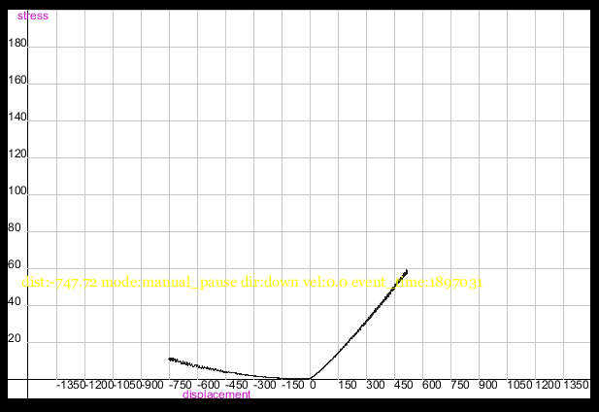

Graph starts to plot when either manual mode or cycle mode is running.

* Manual mode: You can save the graph whenever you want by export button. (see 3.6)
* Cycle mode: Graph will be saved and cleared automatically every half cycle. You can also manually save graphs for elapsed cycles using the export button.

### 

### 3.8 Live Panel:

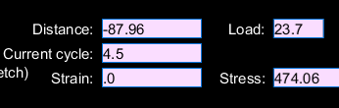

When you conduct the experiment in cycle mode or manual mode, instantaneous outputs i.e. Stress, Strain, Distance, Current cycle, Load will be displayed in the live panel. This live data is stored every instant and when you press “Export” button this values are stored in an excel sheet.

### 3.9 Motor simulation:



A slider is used to simulate the behavior of motor. In case of using the software without hardware interface, the motor simulator can be used to see the behavior of motor. The value near motor simulator shows the value of distance travelled by the motor.

### 3.10 Reset:



Reset button is used to get back the software to its initial conditions. For example, after exporting the data from manual mode or cycle mode, to conduct the experiment with different initial values, you can use “Reset” button and perform the experiment again.